Template for the mantel abstract for
submissions to the 29th GERA-Congress
2024 at the Martin-Luther-Universität
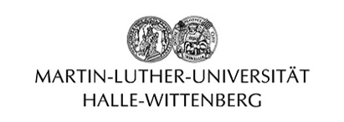
Halle-Wittenberg
[mantel abstract: abstract describing the common focus of the group contribution]

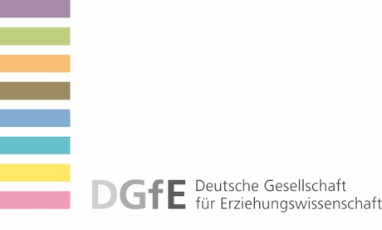

For the congress formats:
Symposia
Working group
Research and thematic forum

Please do not mention the names of the participants in this document, otherwise no review can take place.
When referring to individual presentations, please refer to “Lecture 1”, ”Lecture 2” etc.

For abstracts of individual papers and all other information – including the bibliography – please use the fields provided in the ConfTool-system.

Event title

Abstract (max. 4,000 characters incl. spaces)

